Practical 2
Question:
Develop a C program that uses the system calls open(), read(), write(), and close() to copy the contents of one file to another. Explain how control transitions between user space and kernel space during execution.
Code:
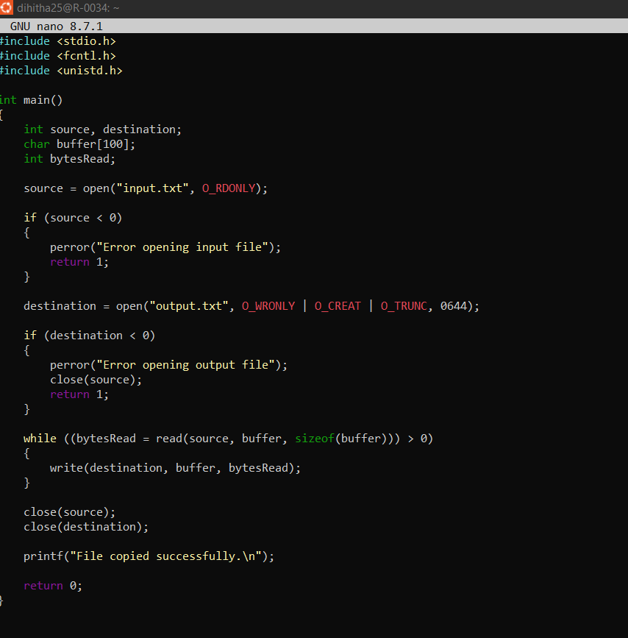
Output:
